SRINIVAS UNIVERSITY
Mangalore-575001, Karnataka (India)

Srinivas Centre for Research in Predictive Analytics

Mrs. GEETHA POORNIMA K
Assistant Professor, Dept of Computer Science
St Philomena College Puttur

Research Area – Predictive Analytics
Predictive Analytics has brought revolutionary changes in many fields. The application areas such as Banking, Education, Sports, Manufacturing, Agriculture, Government, Transportation, Media and Entertainment are the ones that extensively make use of Predictive Analytics. The extraction of Knowledge form data is the most challenging job as the data stored is of different types such as audio, video, text, images and so on. Predictive Analytics is a complex method of exploring big datasets to reveal hidden patterns or unknown relationships, the analysis of which will enable an organization in the decision-making process. It has brought revolutionary changes in many fields of Information Technology. Data contains datasets that are of type audio, video, text, customer transactions, activity logs of users on the social networking sites etc. The data gathered is to be analyzed by using algorithms and has to be converted to required information which can be used for further analysis to arrive at a conclusion or to make a decision. Predictive Analytics is an emerging technology and most of the applications make use of the same in the process of decision making.

Objectives:
The goal of this research centre is to analyze the existing applications in the field of Big Data Analytics and proposing new algorithms to perform Data Analytics.
- To familiarize tools and languages required for Predictive Analytics
- To study the existing solutions and their applications
- To comprehend the use of Predictive Analytics to other emerging technologies

Journal Publications:
- Geetha Poornima K & Krishna Prasad K. Critical Analysis on Business Strategies Adopted by an IT Company to Attain Sustainability: Case Study of Cognizant Technology Solutions. International Journal of Case Studies in Business, IT, and Education (IJCSBE), SRINIVAS PUBLICATION, 2019, 3(2), 14-27
- Geetha Poornima K & Krishna Prasad K. Data Analytics Solutions for Transforming Healthcare Information to Quantifiable Knowledge – an Industry Study with Specific Reference to ScienceSoft. International Journal of Case Studies in Business, IT, and Education (IJCSBE), SRINIVAS PUBLICATION, 2019, 4(1), 51-63.
- Geetha Poornima K & Krishna Prasad, K. Application of IoT in Predictive Health Analysis–A Review of Literature. International Journal of Management, Technology, and Social Sciences (IJMTS), SRINIVAS PUBLICATION, 2020, 5(1), 185-214
- Geetha Poornima K & Krishna Prasad, K. Integrated Prediction System for Chronic Disease Diagnosis to Ensure Better Healthcare, International Journal of Health Sciences and Pharmacy (IJHSP), 4(1), 25-39 SRINIVAS PUBLICATION, 2020,25-39
- Krishna Prasad K., Vinayachandra, Geetha Poornima K. & Rajeshwari M. Literature Review of Applications of ICT on Solar Cold Chain. International Journal of Applied Engineering and Management Letters (IJAEML), Srinivas Publication, 2020, 4, 93-111
- Krishna Prasad K., Vinayachandra, Geetha Poornima K. & Rajeshwari M. An Integrated Solution for Solar Cold Chain Portfolio Management using Internet of Things. International Journal of Applied Engineering and Management Letters (IJAEML), SRINIVAS PUBLICATION, 2020, 4, 112-130
- Krishna Prasad K., Vinayachandra, Geetha Poornima K. & Rajeshwari M. Effect of COVID-19 on Technology Penetration: a Predictive Analysis. Alochana Chakra Journal, 2020, 9, 2949-2967
- Vinayachandra, Geetha Poornima K., Rajeshwari M. & Krishna Prasad K. Role of Technology in the Development of Smart and Secure Public Voting Systems -- a Review of Literatures. International Journal of Management, Technology, and Social Sciences (IJMTS), SRINIVAS PUBLICATION, MANGALORE, INDIA, 2020, 5, 298-317
- Vinayachandra, Geetha Poornima K., Rajeshwari M. & Krishna Prasad K. A Conceptual Framework for the Integrated, Smart and Secure Remote Public Voting System (SSRPVS)
International Journal of Management, Technology, and Social Sciences (IJMTS), SRINIVAS PUBLICATION, MANGALORE, INDIA, 2020, 5, 318-334
- Vinayachandra, Poornima, K. G., Rajeshwari, M., & Prasad, K. K. (2020). Arduino Based Authenticated Voting Machine (AVM) using RFID and Fingerprint for the Student Elections.Journal of Physics: Conference Series, 1712 012004.
DOI: http://doi.org/10.1088/1742-6596/1712/1/012004
- Geetha Poornima K., Rajeshwari M, Vinayachandra, & Krishna Prasad K (2020). Integration of Adaptive Technologies with Healthcare for the Early Identification and Control of COVID-19 Pandemic Disease. International Journal of Health Sciences and Pharmacy (IJHSP), 4(2), 5-28.
DOI: http://doi.org/10.5281/ZENODO.4063845
- Rajeshwari M, Vinayachandra, Geetha Poornima K& Krishna Prasad K. (2020). Web-Oriented Things Systems with 5T Policy to Manage and Contain COVID-19. International Journal of Applied Engineering and Management Letters (IJAEML), 4(2), 138–158. DOI: http://doi.org/10.5281/ZENODO.4063922
- Krishna Prasad K., Aithal P. S., Geetha Poornima K., & Vinayachandra, (2021). Tracking
and Monitoring Fitness of Athletes Using IoT Enabled Wearables for Activity Recognition and Random Forest Algorithm for Performance Prediction. International Journal of Health Sciences and Pharmacy (IJHSP), 5(1), 72-86
DOI: http://doi.org/10.5281/ZENODO.4706576
- Krishna Prasad, K., Aithal, P. S., Geetha Poornima, K., & Vinayachandra, (2021). An AI-based Analysis of the effect of COVID-19 Stringency Index on Infection rates: A case of India. International Journal of Health Sciences and Pharmacy (IJHSP), 5(1), 87-102.
DOI : http://doi.org/10.5281/ZENODO.4732767
- Vinayachandra, Geetha Poornima K., Rajeshwari, M. & Krishna Prasad, K. (2021).
Students’ Perception of the Effectiveness of Technology Assisted Online Education DuringCOVID-19 Pandemic: An Empirical Study. International Journal of Management,
Technology, and Social Sciences (IJMTS), 6(1), 203-225.
DOI : http://doi.org/10.5281/ZENODO.4922352
- Geetha Poornima K., Vinayachandra, Rajeshwari M. & Krishna Prasad K. (2021). The
Effect of Integration of Different Online Education Methods on Educational Advancement and Student Development: A Study. International Journal of Case Studies in Business, IT, and Education (IJCSBE), 5(1), 200-220.
DOI : http://doi.org/10.5281/ZENODO.5059665
- Krishna Prasad K., Vinayachandra, Geetha Poornima, K., & Rajeshwari, M. (2021). Students’ Perceptions of the Impact of Online Education on Health during COVID-19: A Survey Study. International Journal of Health Sciences and Pharmacy (IJHSP), 5(2), 1-27. DOI:http://doi.org/10.5281/zenodo.5149609.
- M., Rajeshwari, Vinayachandra, K., Geetha Poornima, & K., Krishna Prasad, (2021). An
Analysis into the Contribution of Google Applications in the Successful Implementation of Online Education During the COVID-19 Pandemic. International Journal of Applied
Engineering and Management Letters (IJAEML), 5(1), 131-152.
DOI:https://doi.org/10.5281/zenodo.5091214
- Geetha Poornima K, Vinayachandra, Rajeshwari M, & Bishwas Mishra (2021). An Analysis into the use of Supervised Learning Algorithms in Predictive Analytics. Sparkling light Transactions on Artificial Intelligence and Quantum Computing, 1(2), 1-20.

Publication in Conference Proceedings

- K. Geetha Poornima, Krishna Prasad K. (2019). A Study on The Measures Taken by Cognizant Technology Solutions for Achieving Sustainable Growth In The Digital Market, International Conference on Emerging Trends in Management, IT and Education-2019. 71-84 ISBN: 978-81-941751-2-4, pp no 71-84.
- Geetha Poornima K., Krishna Prasad K. (2019). Data Analytics Services Kits For Converting Healthcare Data into Actionable Insights – Sciencesoft A Case Study, National Conference on Recent Advances in Technological Innovations in IT, Management, Education and Social Sciences, 86-94. ISBN No: 978-81-941751-6-2.
- Geetha Poornima K. (2020). “A Conceptual Cloud-Based Framework for Fitness Tracking and Performance Prediction of Swimmers” National Level Paper Contest for Ph.D. students. 21st November 2020. 31-36. ISBN: 978-81-944670-1-4.

Application for Grant of Patent
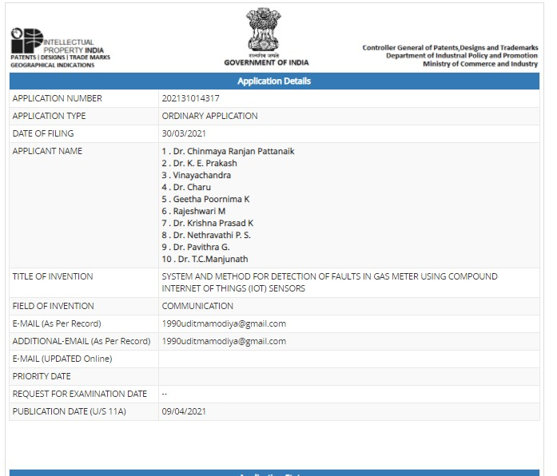
Working Papers:
- A Systematic Approach to Cloud-Based Fitness Tracking and Performance Prediction
- Random Forest Algorithm in Predictive Analysis – an overview.
- The Effect of Tracked Fitness Index on the performance of swimmers: A Predictive Analysis.

Copyright
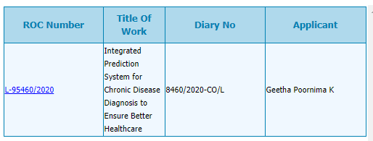

Membership in Professional Bodies
- Graduate Student Member – No. 96697229 (Bangalore Section)

Research Scholar:
Mrs. Geetha Poornima K
Assistant Professor, Dept of Computer Science
St Philomena College, Puttur, D.K. 574202 KARNATAKA
&
Research Scholar,
College of Computer Science & Information Science
Srinivas University, City Campus, Mangaluru - 575001
E-mail: poornima.sanjay@gmail.com, poornima.sanjay@spcputtur.ac.in
College Website : www.spcputtur.org
University Website: www.srinivasuniversity.edu.in

Profile in Popular Research Work Uploading Sites
ResearchGate | https://www.researchgate.net/profile/Geetha-Poornima-K
Google Scholar | https://scholar.google.com/citations?user=bojWU7YAAAAJ&hl=en
ORCID | https://orcid.org/0000-0001-9095-0349
Academia.edu | https://independent.academia.edu/Geethapoornima1
SSRN | https://hq.ssrn.com/submissions/MyPapers.cfm?partid=3781194
Mendeley | https://www.mendeley.com/profiles/geetha-poornima-bhat/
Vidwan | https://vidwan.inflibnet.ac.in/profile/219275

Research Guide:
Dr. Krishna Prasad K.
Associate Professor,
College of Computer Science & Information Science
Srinivas University, City Campus, Mangaluru – 575001

E-mail : krisshnaprasadkcci@srinivasuniversity.edu.in, karanikrishna@gmail.com
Personal Website: www.krishnaprasadk.website
College Website: www.srinivasgroup.com
University Website: www.srinivasuniversity.edu.in

